**DAILY ONLINE ACTIVITIES SUMMARY**

|  |  |  |  |  |  |  |  |  |
| --- | --- | --- | --- | --- | --- | --- | --- | --- |
| **Date:** | **20-05-2020** | | | | | **Name:** | **PRAJNA** | |
| **Sem & Sec** | **VI & A** | | | | | **USN:** | **4AL17CS059** | |
| **Online Test Summary** | | | | | | | | |
| **Subject** | | **SSCD** | | | | | | |
| **Max. Marks** | | **30** | | **Score** | | | **20** | |
| **Certification Course Summary** | | | | | | | | |
| **Course** | **Introduction to Information Security** | | | | | | | |
| **Certificate Provider** | | | **GREATE LEARNING** | | **Duration** | | | **6 HOURS** |
| **Coding Challenges** | | | | | | | | |
| **Problem Statement:4 PROBLEMS** | | | | | | | | |
| **Status:2 COMPLETED** | | | | | | | | |
| **Uploaded the report in Github** | | | | | **YES** | | | |
| **If yes Repository name** | | | | | <https://github.com/prajna-nayak-098/prajna--online-code> | | | |
| **Uploaded the report in slack** | | | | | **YES** | | | |

Online Test Details: (Attach the snapshot and briefly write the report for the same)

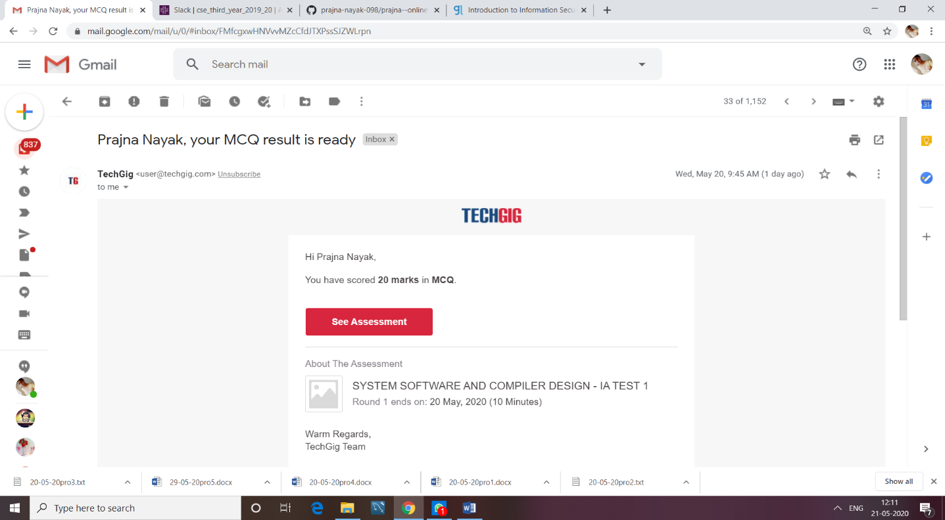

Certification Course Details: (Attach the snapshot and briefly write the report for the same)

Coding Challenges Details: (Attach the snapshot and briefly write the report for the same)